# HOW TO CONNECT STS TO DATABASE

## STEP :-

FIRST CREATE DATABSE BELOW

STEP:-2

Click on the pointed icon

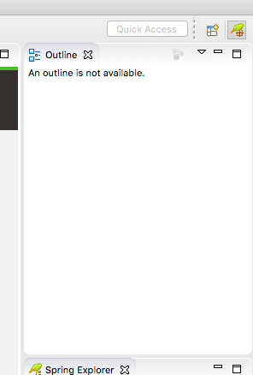

Select the Database Development

## To learn more and get

## And then click open

## Then select and right click on Database connections and select new

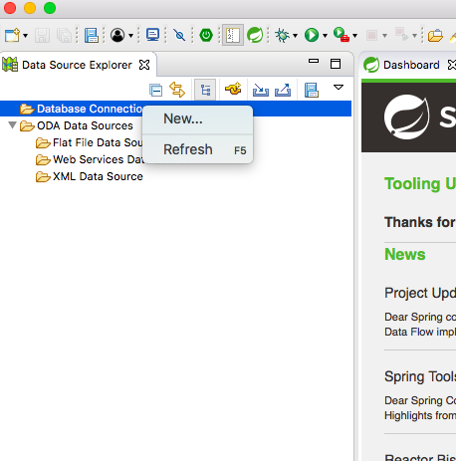

## This will open below window select database as your project

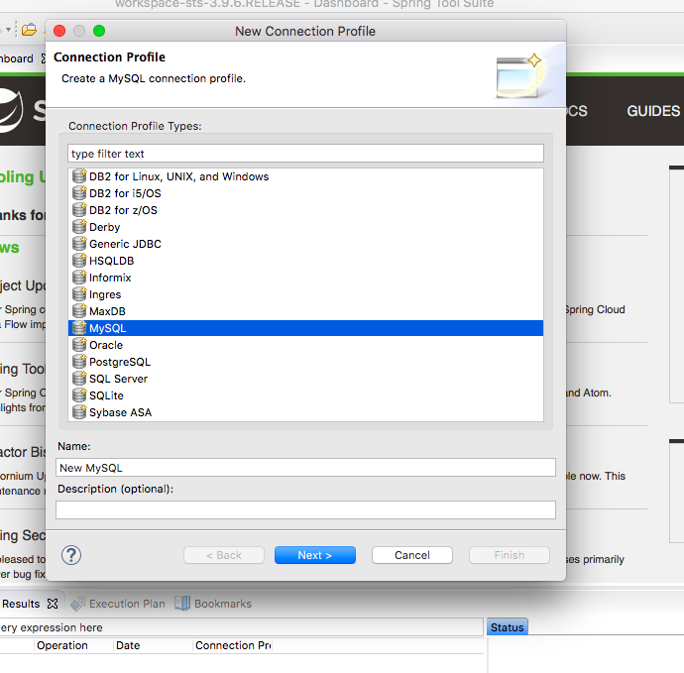

And Select next , this will open new Window

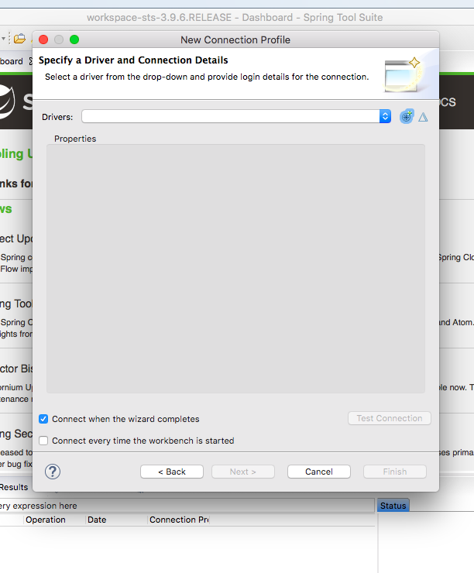

## 

## Click on remove Jar and Select Add JAR

Locate Driver Class [MySql Connector JAR] file on your system and click open

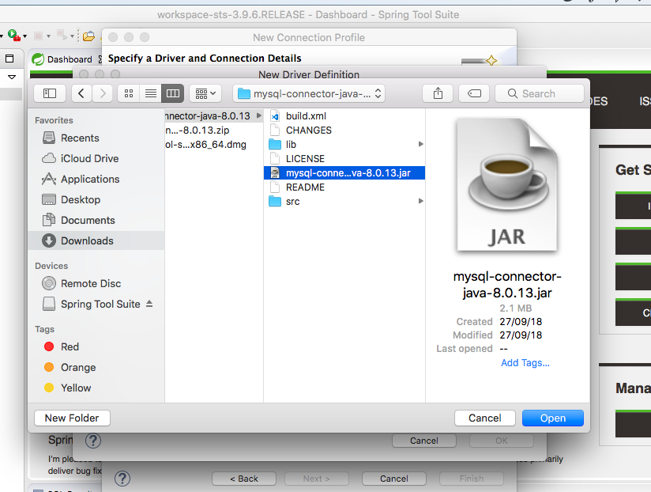

## Then Click on ok will open below window

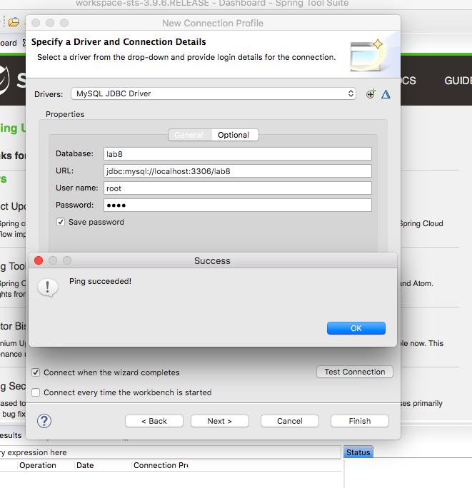

## Click on Test Connection

If all parameters are correct ping succeeded will appear.

Click ok and click finish

This will connect your STS with your Database with Eclipse.

## OneNote, visit [www.onenote.com](http://go.microsoft.com/fwlink/?LinkID=523891).